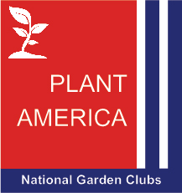
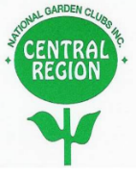
NGC Central Region Unified Project Award Application Form
“PLANT AMERICA: Your Garden Club
Makes Progress Possible!”

Applicant Information (DEADLINE for application: September 16, 2027)
Please provide the following details for your application:
- Date Submitted: __________________________
- Name of Garden Club, town/village/city and state as it should appear on the award certificate:
__________________________________________________________________
__________________________________________________________________
- Contact Person: ______________________________________________________________________
- Telephone: _______________________________
- Email: _____________________________________

Submission Guidelines
To support environmental sustainability, all members are encouraged to submit their entries electronically rather than using additional natural resources.
If you are unable to send your entry electronically, please contact the Central Region Unified Project Chair before submitting. For manual submissions, please adhere to these guidelines:
- Include a brief summary of the project and include articles and photos submitted to the Central Region Newsletter. Include information on club collaboration with another group/organization to complete the project. (Hint! Highly encouraged!)
- For manual submissions, attach photos to the pages. For electronic submissions, insert photos within the document.
- Keep a copy of your application for your records, as applications will not be returned.

Submission Instructions
Send the completed application electronically to:
- NGC Central Region Unified Project Award Chairman: Carol Yee
- Email: mscyee@hotmail.com
- Questions? Contact Carol Yee by email or phone: (708) 927-9937
If you must submit your application by mail, send it to:
NGC Central Region Unified Project Award Chairman
5224 Grand Ave.
Western Springs, IL 60558

