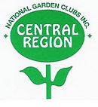
NGC Central Region Unified Project
PLANT AMERICA:
Your Garden Club makes Progress Possible!
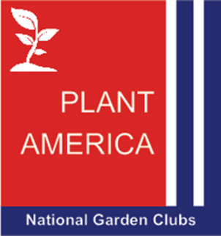

“Each club is different in its own way, but we all value nature and our environment, education, gardening, floral design and our community. Clubs do amazing projects and deserve to be recognized!”
The goal of Rene Lynch’s NGC Central Region Director’s Unified Project is to recognize Central Region garden clubs for progress on new projects during her term (2025-2027): The project must have begun after June 1, 2025 and can be any new club project or one that focuses on National Garden Club’s new project “PLANT AMERICA: Red, White and Blue” for our nation’s 250th Birthday in 2026. Collaboration with another group or organization is encouraged.
Garden clubs qualify for the NGC Central Region Unified Project award by submitting an article (with photos) about their project to the Central Region Newsletter. After publication, the article and the NGC Central Region Unified Project Award application form must be submitted for review before September 16, 2027. Four clubs will be selected to receive recognition and a monetary award for outstanding new projects at the 2027 NGC Central Region Convention. We’re looking forward to hearing about your club projects throughout Central Region, so please submit articles to the CR newsletter!
Award forms are on the Central Region website: ngccentralregion.com Two $25.00 recognition awards for clubs with 20 members or less and two $25.00 recognition awards for clubs with over 20 members will be given. Each club that applies for the award will receive a certificate of recognition.
Rene Lynch, NGC Central Region Director, encourages all clubs to make PROGRESS POSSIBLE. “Let’s do it together”.
Carol Yee
NGC Central Region Unified Project Award Chairman
mscyee@hotmail.com

