Date Submitted: _________________________________
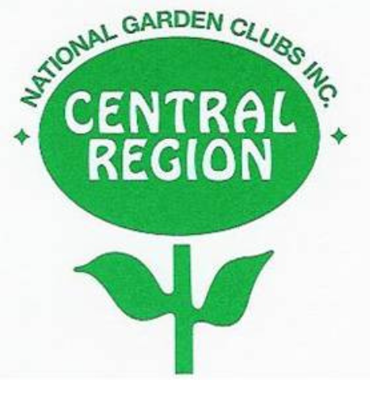CENTRAL REGION AWARD APPLICATION

Award No.: ___________ Award Name: ____________________________________________________

Name of Applicant: ____________________________________________________________________
(State or State Garden Club written exactly as it should appear on the award certificate)
Council or Member making the application: _______________________________________________

Contact Person: ________________________________________________________________________

Telephone: _______________________________ Email: _____________________________________

Effective with the 2023-2025 term, NGC is requiring all Award Applications to be sent
electronically. Central Region will follow their lead. Because the NGC theme is GO
GREEN-PLANT AMERICA, we are encouraging all members to submit electronic
entries rather than use up more of our natural resources.

● If you are unable to submit a Central Region entry electronically, please contact the CR
Awards Chair prior to submitting. The following guideline should be followed:
1. Application is limited to three pages, front of pages only. No report cover, binder or
plastic sheets. (for manual submission) CR Application is page one.
2. Give a brief summary of the project, including photos, letters, financial information,
publicity or other supporting data.
3. Photos may be attached to pages (manual submission) or inserted electronically.
4. Keep a copy for your records, as the application will not be returned.
● Send the completed three pages electronically to:
Central Region Awards Chairman, Kerry Krokos at Krokos.L4030@sbcglobal.net
● If you need to send by mail, send to:
Central Region Awards Chairman, Kerry Krokos
8640 W. Spokane St.
Milwaukee, WI. 53224
Cell Only:414-628-4545

