

**“Sharing Perspectives”**

Wisconsin Symposium

Oct. 27-28, 2025

Location: The Osthoff Resort

101 Osthoff Avenue

Elkhart Lake, WI 53020-0151

Room Reservations

800-876-3399

Identify: WI Symposium

Or Central Region Convention

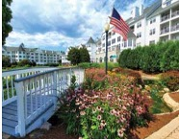

Chair: K. Larkin [kittysltr@wi.rr.com](mailto:kittysltr@wi.rr.com)

V Chair: Liz Murken [lmurken@gmail.com](mailto:lmurken@gmail.com)

Coordinator: Norma McReynolds normamcreynolds@gmail.com

**Monday, October 27, 2025**

**HORTICULTURE**

Instructor: David Robson

Subjects: Apples & Displays

8:30 Registration

9:00 Announcements

9:15 Apples & Displays

10:15 Break

10:30 Apples & Displays

11:30 Lunch

12:30 Oral Point Scoring

2:30 Break

2:45-4:45 - Written Pt. Score Exam

NOTE: Check the WGCF or Central

Region Website for the Photography Contest schedule **“Reflective – Photography”** and registration for contest prior to August 1, 2025. Any Federated Garden Club Member may enter.

**Tuesday, October 28, 2025**

**DESIGN**

Instructor: Lynn Fronk

Subjects: Illuminary & Reflective

Designs

8:30 Registration

9:00 Announcements

9:15 Illuminary & Reflective

10:15 Break

10:30 Illuminary & Reflective

11:30 Lunch

12:30 Oral Point Scoring

2:30 Break

2:45-4:45 - Written Pt. Score Exam

6:00 **Dinner** and **ALLIED TOPIC –**

**PHOTOGRAPHY**

Speaker: Arabella Dane,

Photography Instructor and

Photography Society of America

Judge

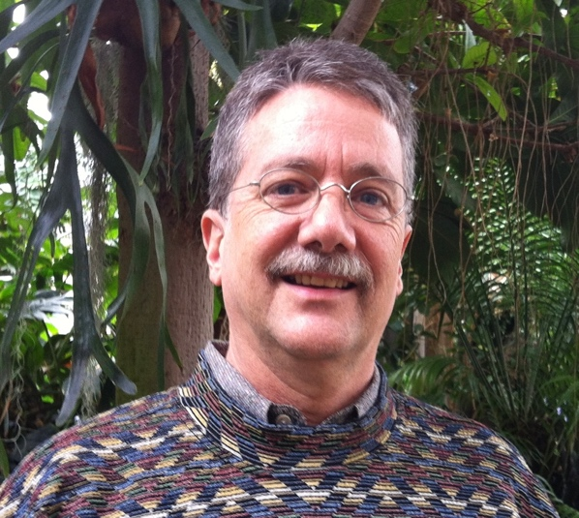

**David Robson, Horticulture Instructor**

David Robson is a retired horticulture and pesticide safety specialist with the University of Illinois. He was president of the Springfield Civic Garden Club from 1995-1997, after serving on the board of directors for many years. He currently is the Co-Treasurer of the Club. He has served 10 years (2 different terms) as the Garden Clubs of IL Awards Chairman. He currently is the 3rd Vice-President. He has been a National Garden Club Master Judge since 1992, and Flower Show School and Symposium instructor since 2008. He also has been an IL State Fair Culinary Judge for the past 14 years.

He currently serves on the NGC Board of Directors as Vice Chair of the Flower Shows and Flower Show School Committee, as well as the Horticulture Instructors and Credentials chair; he is an NGC PH&E Trustee.

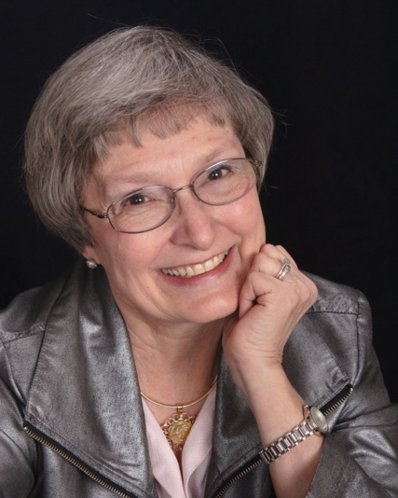

**Lynn Fronk, Design Instructor**

Lynn is an NGC Master flower Show Judge, Flower schools Design and Flower Sow Procedure Instructor. She has taught in 42 States, Mexico, Guatemala, Columbia, Ecuador, Uruguay and Guantanamo Bay, Cuba. She has judged major flower shows in the United States such as the Philadelphia Flower Show, Newport Flower Show and the Rhode Island state Flower Show.

Lynn is a Past President of GC of Ohio. She is a member of the Flower Show Schools Committee serving as the Co-Symposium Chairman for NGC, the Symposium Chairman for the GC of Georgia and has recently relocated from Ohio to Flowery Branch, Georgia. She is a Master Environ-mental Consultant and Gardening Consultant for NGC and author of “Merry Christmas from My House to Yours”.

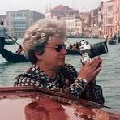

**Arabella Dane, Allied Topic Instructor**

Arabella is an NGC Master Flower Show Judge, Master Landscape Critic and Gardening Study Consultant, and serves on the NGC Board.

A photography instructor, a Photography Society of America Judge, and member of several photography organizations and camera clubs. Arabella gives programs in person and via zoom. She has competed successfully in numerous international competitions. Enjoy some of her images on this link: htttp://www.nanpa.org/showcase-20019-winner-profile-arabella-dane. http://www.nanpa.org/portfolio/arabella-dane-2019/ Arrabella has compiled a plant database of over 150,000 plants and is continually adding images of these plants and the butterflies and other pollinators that frequent them.