2025 CENTRAL REGION CONVENTION

 PERSPECTIVELY

CONNECTED

**Tuesday Dinner Speaker:**

 **Arabella Dane** Photography

How to Make your Smart Phone Camera Work for You

Arabella is an NGC Master Landscape Consultant and Gardening Study Consultant and serves on the NGC Board. Arabella is a photography instructor, a Photography Society of America Judge, and a member of several photography organizations and camera clubs. Arabella gives programs in person and via zoom. She has competed successfully in numerous international competitions. You can enjoy some of her images on this link: <http://www.nanpa.org/showcase-20019-winner-profile-arabella-dane-2019/> Arabella has compiled a plant data base of over 150,000 plants and is continually adding images of these plants and butterflies and other pollinators that frequent them. Her program will help you make your smart phone camera work for you.

**Wednesday Lunch Speaker:**

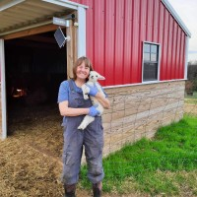 **Beth Ivankovic** Ewe and Me Wool Company, LLC

Wooly Belly Pellets

Beth Ivankovic and Janell Sworski started Ewe and Me Wool Company, LLC in 2023. Both women are shepherds and gardeners in addition to being passionate about the environment. Wolly Belly Pellets incorporate all three passions! Beth and Janelle have developed Wolly Belly Pellets from the wool of their sheep. The pellets are environmentally friendly and naturally enriches the garden soil. This product is a sustainable replacement for peat moss; it aerates and adds porosity to the soil; it leads to less watering in the garden or potted plants, and it fertilizes the plants (NPK ratio of 9-0-3). Beth will be presenting a very interesting and informative talk on raising sheep and using the wool from their sheep to make these pellets. You will surely be inspired by Beth’s presentation.

**Wednesday Dinner Speaker:**

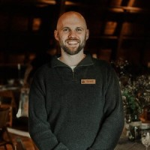 **Ryan Laswell** Executive Director Nourish Farms

Ryan is the Executive Director of Nourish Farms, an organization that focuses on Farm to School and Farm to Community programs on their 13 acres that have 32,000 engagements per year.   He has worked in the grocery industry for nearly a decade, in corporate wellness, and at Vanderbilt University in Cardiac and Pulmonary rehab.  Ryan has been an advocate for the environment, composting, and understanding how our food choices can have a symbiotic relationship with the land around us.  His passion for food, health, and the environment stems from his schooling at UW Stevens Point and abroad in Austria.  In his free time, Ryan has volunteered compost collecting, environmental clean-up, and coaching soccer for his two daughters.  He and his wife operate a small urban farm in Sheboygan and help on local farms in the county that focus on vegetable production.

**Thursday Lunch Speaker:**

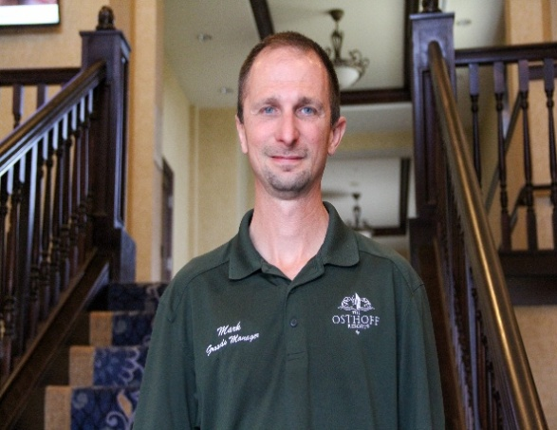 **Mark Roehrig** Grounds Manager Osthoff Resort

Mark started his professional journey as a landscape technician, a role he held for four years. This position exposed him to the diverse facets of the landscape industry, including landscape construction installations, arboriculture, landscape design, landscape maintenance, and integrated pest management. His dedication and growing expertise led him to become a Landscape Maintenance Foreman at Kohler Company. Over 14 years in this role, Mark honed his skills in maintaining high-end properties, working around prestigious golf courses, hotels, shopping centers, corporate headquarters, and even Kohler family homes.

For the past 12 years, Mark has been the Grounds Manager at The Osthoff Resort. His responsibilities encompass a wide array of landscape maintenance practices, such as turf maintenance, annual flower installations, new landscape installations, plant health care practices, hardscape installations, holiday lighting and décor, and property events, to name just a few. Mark's enthusiasm for caring for this high-end property brings immense joy and gratitude to both guests and owners. Mark believes that landscape maintenance is truly a science. As he puts it, "Just when you think you've learned how to care for a plant, science changes, and you have to adapt to today’s environment." His commitment to staying updated with the latest advancements ensures that The Osthoff Resort's grounds remain a beautiful and welcoming space for all to enjoy.

**Thursday Dinner Speaker:**

**Janet Raddatz** - Master Naturalist

PLANTS FOR BIRDS & POLLINATORS

Can you imagine a world without birds or other pollinators? The benefits that these creatures bring are critical to us. Birds play an essential role in the functioning of the world’s ecosystems, in ways that directly impact human health, economy, and food production. Bird populations are declining; 2.9 billion birds are gone since 1970! Learn how incorporating native plant species into your landscape can help our birds and other pollinators.

Janet and her husband, Andy, are avid bird watchers. Realizing the importance of habitat for our native species, they restored their yard of grass back to native southern mesic woodland over 20 years ago. Since 1999 Janet has been sharing her knowledge of Wisconsin’s bats and frogs with children and adults. In 2015 Janet and Andy became Wisconsin Master Naturalists.

Janet and Andy participate in BRAW – Bluebird Restoration Association of WI – where they monitor bluebird boxes in spring and summer and report fledge success. They have been the International Crane Foundation Annual Crane Count Coordinators for Sheboygan County since 1998 and have participated in the Crane Count since 1982. Since 2018 she and her husband have been leading a weekly Discovery Bird Walk at Kohler Andrea State Park.

Janet Raddatz has retired from a career in quality and food safety. She holds a master’s degree in quality from Marian College, WI and a bachelor’s degree in biology from the University of Wisconsin-Green Bay**.**

**Workshops:**

**Wednesday Workshop:**

**Maureen Wild Gordon & Jill Helgeson**

Bird Seed Wreaths - Make your own bird seed wreath to take home and feed the birds. Don’t let the birds go hungry!

**Thursday** **Workshop:**

**Wendy Kramer & Lynne Ehnert**

Wind Chime – Make your own wind chime to hang in your yard. Let’s see how you shine!